**EXPERIMENT 1 : GOOD DESIGN VS BAD DESIGN IN FIGMA**

**Aim:**

To create and analyze good and bad UI designs using Figma, understanding how design principles affect user experience.

**Procedure:**

**Step 1: Setting Up the Experiment**

1. **Open Figma and Create a New File**
   * Go to Figma and log in.
   * Click **“New File”** to start designing.
2. **Set Up Two Frames for Comparison**
   * Click on the **Frame Tool (F)** and create two separate frames:
     + **Frame 1: Good UI Design**
     + **Frame 2: Bad UI Design**
   * Give each frame a **name** (e.g., "Good Design" and "Bad Design").

**Step 2: Designing the Good UI (Frame 1)**

1. **Apply Good UI Principles:**
   * Use a **grid layout** to align elements properly.
   * Select a **clear and readable font** (e.g., Roboto, Inter) with proper size and spacing.
   * Maintain a **high-contrast color scheme** for better readability.
   * Design buttons with **proper size, padding, and clear labels** (e.g., “Login” instead of “Click Here”).
   * Keep the layout **consistent and structured**, ensuring a smooth navigation flow.
   * Add relevant **icons and high-quality images** to enhance the design.
2. **Test Good UI Usability:**
   * Check if users can **easily navigate** the design.
   * Use **Prototype Mode** to simulate interactions.

**Step 3: Designing the Bad UI (Frame 2)**

1. **Introduce Poor UI Practices:**
   * Avoid using a **grid**, leading to misaligned and cluttered elements.
   * Use **inconsistent or unreadable fonts**, making the text difficult to read.
   * Pick **poor color combinations**, such as bright neon colors or low contrast between text and background.
   * Design buttons that are **too small, unclear, or placed in unexpected positions**.
   * Overload the layout with **too many elements, unnecessary text, and distracting images**.
2. **Test Bad UI Usability:**
   * Simulate user struggles with readability and navigation.
   * Compare with the good UI design for differences.

**Step 4: Evaluation and Analysis**

1. **Compare Both Designs:**
   * Place both frames side by side and analyze the differences.
   * Observe how good UI design enhances usability, while bad UI design creates confusion and frustration.

**Output :**

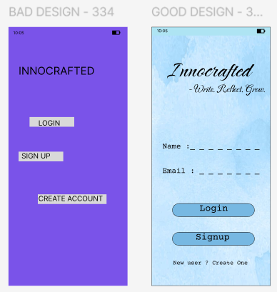

**Results:**

The **good UI design** was easy to navigate, with clear text, proper color contrast, and well-placed buttons. Users found it intuitive and visually appealing.

The **bad UI design** was cluttered and difficult to use. Poor alignment, low contrast, and unclear buttons caused confusion and frustration for users.

**Link :**

https://www.figma.com/design/cuhGONS98y1ErYPQjKIMBh/230701334---SREYA-G---EXP-1----GOOD-DESIGN-VS-BAD-DESIGN?t=nEKZ0jUAHck25XSy-1